**Assignment -4**

Digital Marketing

|  |  |
| --- | --- |
| Student Name | Jothi Anantha Kumar D |
| Student Roll Number | 20URCS018 |
| NM ID | 9EEA217E4294145B2C0498F030D9E2DC |
| College Name | AAA College of Engineering and Technology |

**QUESTION:**

**Create email newsletter design using MailChimp or Canva tool.**

**EMAIL NEWSLETTER USING CANVA:**

**Newsletter link:** <https://www.canva.com/design/DAFt1JQwUdE/EldXFOwDdqULfGiN7HL3Dg/edit?utm_content=DAFt1JQwUdE&utm_campaign=designshare&utm_medium=link2&utm_source=sharebutton>

**NewsletterTitle: CNC LATHE MACHINE**

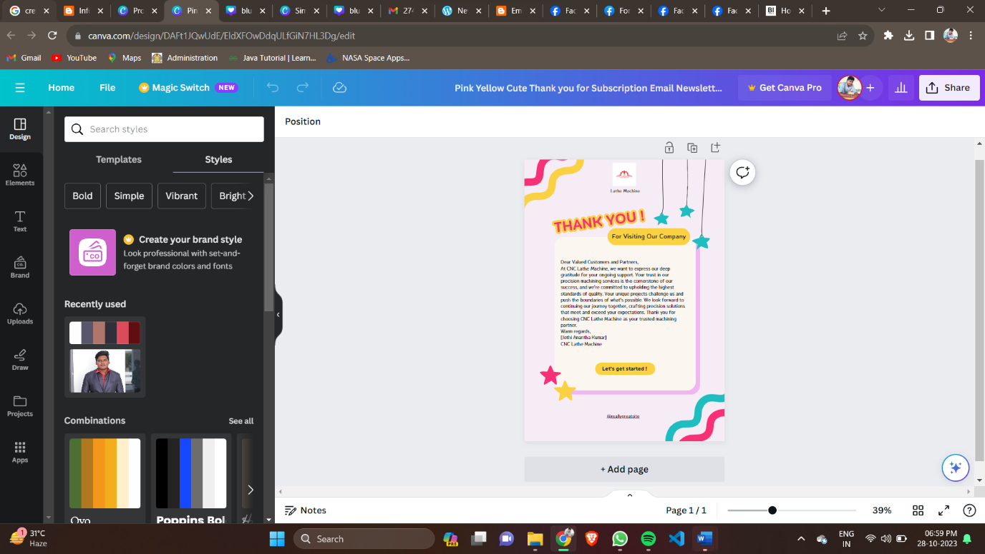

**Email Newsletter:**

